Mobile handset antenna

Handset antenna is an essential device for the mobile communication system. It is a critical element that can either enhance or constrain system performance. The development cellular handsets have experienced rapid growth and evolution ever since it was first introduced in the 1980s. In the past, the mobile communication devices are heavy, large and require high power to operate. The first type of antennas recognized for mobile communication devices were wire antennas such as monopole antennas. These antennas can achieve high gains, are simple to design and have wide bandwidth. The design of handset antennas received much attention along with the development of cellular handsets. Nowadays, handsets have become more attractive, lighter and smaller. Hence, internal or built in antennas are more preferred than conventional wire antennas which are external to the cellular handset.
In the 1990s, handsets that can operate in two cellular frequency bands have become the minimum requirement in Europe. Multiband handsets allow users to use the same cellular phone in multiple networks that has different operating frequency band. In the current mobile communications system, the handset is no longer a voice only mobile unit. For example, the third generation mobile handsets that operate in the IMT-2000 frequency band offer high-end service capabilities like video-on demand high speed multimedia data services and mobile Internet access. As the functions of the handsets expand, multi-antenna integration in one handset is required.
Wire antennas, such as the monopole and the modified monopole antennas (see Figure 1), were the first type of antennas recognized for mobile communication devices. They are easy to design, light weight, and have omni-directional radiation pattern in the horizontal plane [5]. However, since the physical length of a monopole antenna is quarter of its wavelength at the operating frequency, this antenna is relatively very long. Therefore, monopole antennas are usually external antennas. As the size of handheld devices was decreasing, the invertedL antenna (ILA) was found to be a promising alternative to replace the external monopole antenna. The ILA is an end-fed short monopole with a horizontal wire element placed on top that acts as a capacitive load (see Figure 2). The design of the ILA has a simple layout making it cost efficient to manufacture [3].
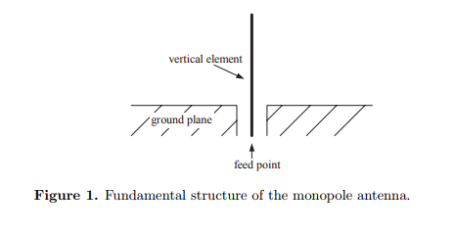
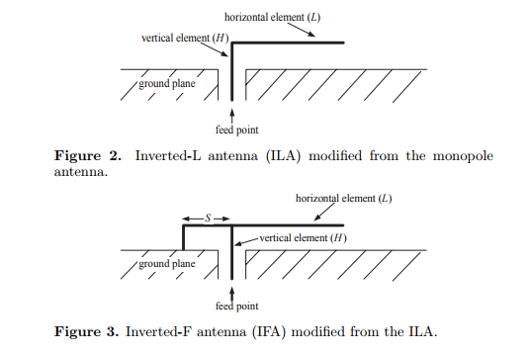
Although the radiation properties of the ILA have advantages over those of the monopole antenna by radiating in both polarizations due to the horizontal arm, however, its input impedance is similar to that of the short monopole: low resistance and high reactance. This prompted antenna designers to search for an antenna with nearly resistive load thus provides reduced mismatch loss. For this purpose, the inverted-F antenna (IFA) was introduced (see Figure 3) [6, 7], which adds a second inverted-L section to the end of an ILA. The additional inverted-L segment introduces a convenient tuning option to the original ILA and greatly improves the antenna usability. Even with the improvement in the match of the IFA over the ILA, both these antennas have inherently narrow bandwidths. To obtain broad bandwidth characteristics, antenna designers transformed the horizontal element from a wire to a plate (see Figure 4), and the planar inverted-F antenna (PIFA) was introduced [8]. The PIFA is widely used in nowadays mobile handheld devices. It is a self-resonating antenna with purely resistive impedance at the frequency of operation. This makes it a practical candidate for mobile handheld design since it does not require a conjugate circuit between the antenna and the load reducing both cost and losses. Despite the relative simple design of the ILA, IFA, and the PIFA, the optimal design of any of these antennas is not unique (see Figures 2–4).
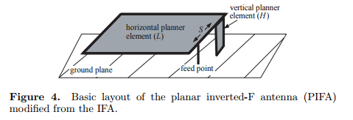
Variations in the height of the radiator (H), the length of the horizontal element (L), the distances and the location of the feed and the shorting point (S), etc. all affect the electrical performance of these antennas. Numerous designs have been reported in the literature, e.g., [5–18]. Many of them suggest approaches to further improve the bandwidth and the performance of these antennas, e.g., [9, 18]. To the best of our knowledge, there has been no theory that can describe the behavior or the design procedure of these antennas. The best that can be found in the literature is some design recommendations based on the trial and error procedures that take place in the antenna laboratories while building the antenna prototypes or from the numerical simulations.
The evolution of the handset antenna designs from a monopole to the PIFA indicates that that the essential component of a handset antenna is the “wire”. The patch(s) slot(s), and stub(s) are only used to compensate for the mismatch and improve the radiation characteristics. Notice that at the megahertz frequency range, the current flowing on the surface of a conductor no longer has a uniform distribution due to the skin effect, but it is confined to a relatively small area. Therefore, the effective cross-sectional area of the conductor is smaller than the actual dimension [19].
For example, by simulating a basic PIFA and examining the current distribution on its surface at the frequency of operation, one can see that the current distribution is concentrated at the edge(s) of some of the antenna parts. Therefore, the length of these edge(s) where the current is concentrated is the major parameter that tunes the antenna to that desired frequency [3, 10]. The remainder of the conductor plate(s) forming the patch(s) of that antenna part is, therefore, not an essential part in tuning the antenna but are rather to improve the antenna characteristics. In fact, removing these parts would affect the matching of the antenna and would not detune it much. From this intuition, we propose a new procedure in handset antenna design. As a first step in the design, we represent the antenna by the fundamental wires responsible for its tuning at the frequencies of operation, and these become the backbone of the final design. We then derive an analytical solution for this wire model representation. Using this analytical solution, the antenna designer can easily and efficiently design the antenna that is tuned to the desired frequency by only solving a few analytical equations, no simulations or prototypes are required. The designer can further improve the basic design by adding patch(s), stub(s), slot(s) or a combination of these to reduce the mismatch and to improve the radiation characteristics.
Using the wire model to represent the antenna raises a question — would it be possible to achieve multi-band operation with broadband performance using the “wire” only? We have come to find the answer to this question by introducing a three-dimensional (3D) monopole antenna. This novel design has the virtues of simplicity and smaller maximum size than any known handset antenna design to date.
The PIFA has been considered to be the most favorable antenna for handheld devices. However, our novel design outperforms the PIFA for a given maximum antenna size. It has a remarkably wider bandwidth, an impressively simpler structure, and its performance is less affected by the environment compared to the PIFA.
WIRE MODELS FOR HANDSET ANTENNAS
To illustrate the idea of the thin wire model, we introduce a numerical example of a PIFA and represent it with its equivalent thin wire model. Consider the antenna shown in Figure 5(a) [25–29]. The equivalent wire model for this antenna is shown in Figure 5(b) where the planar surface of the antenna is replaced by a wire along its outer edges.
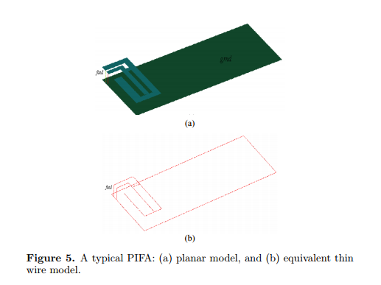
The radius of the wire can be very small, here we choose a/λ = 10−4. The ground plane is replaced by an equivalent wire loop that is connected to the wire antenna model at the feed and at the shorting points, respectively. A key factor in the design of an antenna is the current distribution on its surface. This distribution can provide information on the resonating element(s), and hence, the controlling element(s), at each frequency of interest. These elements become design parameters in tuning the antenna.

